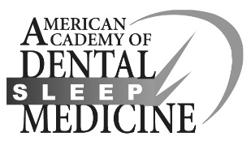
American Academy of Dental Sleep Medicine
Presenter Agreement

The American Academy of Dental Sleep Medicine (AADSM) requires that all potential speakers for the 2019 AADSM Annual Meeting complete and submit this form along with the session proposal submission. The completed form can be submitted via fax to Beverly Basit, Meeting Planner, at (630) 686-9876.

Name:

Session Type:

Presentation Title:

Check each of the boxes below to agree to the conditions of this release:

I represent that the content of the presentation(s) is accurate to the best of my knowledge.

I represent that the presentation(s) are my own original work and will not infringe on any personal or property rights of any other person or organization, or I have secured any necessary permission to include copyrighted material in the presentation.

I agree that the AADSM has permission to include my PowerPoint presentation(s) in a compilation of conference materials in paper format. If PowerPoint presentations are not submitted by Monday, May 6, 2019, the AADSM has permission to post a pdf of the presentation on a secured website accessed by registered meeting attendees via a link. The presentation will be available on this website from the date it is received until 30 days past the event.

I agree to indemnify, defend and hold AADSM harmless from and against all claims, expenses (including attorneys’ fees) and liability arising, directly or indirectly, from a breach of any warranty or representation I have made in this agreement.

I agree that any images used in my PowerPoint presentation(s) are authentic and have not been falsified to misrepresent treatment outcomes.

Signature:

Print Name:

Date:

Replace empty box with checked box to represent electronic signature:

